**Noovos Search Investigation and Planning**

**THIS ANALYSIS IS BASED ON APPS ONLY SO FAR**

**Version 2025-04-07**

We did some competitor research regarding the search. It’s probably a major factor in the success of Noovos. Feel free to interject at any time but the best way forward is to put something together and allow you to change if needed. You know more about booking beauty treatments than I do for sure.

However, as a new user on both Fresha and Vigaro I was extremely underwhelmed.

I just wanted a haircut.

Vigaro crashed when I wasn’t sure about a haircut at 2:15 tomorrow in South London.

Fresha confused me. I didn’t know what to search for first or where. Eventually got the hang of it and found some places in Shrewsbury.

I suppose I could have considered San Francisco (Not sure why the image is inversed, but you get the point)

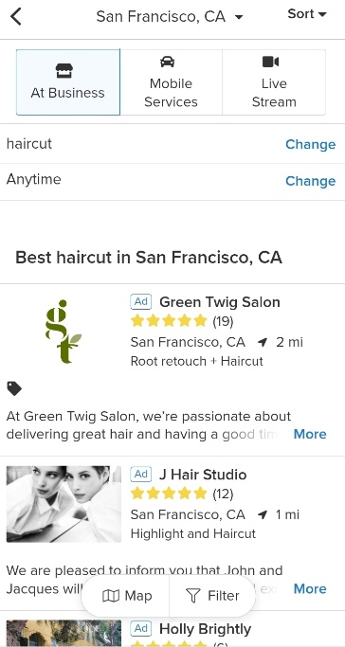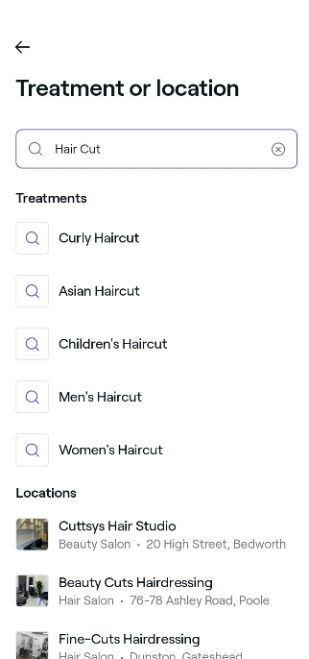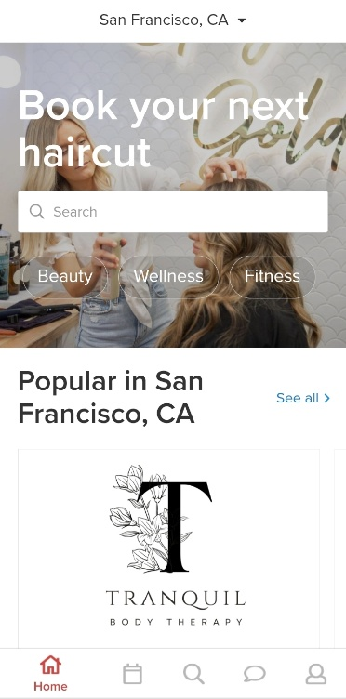

Factors in question

SEARCH BAR

We can allow users to just type something, and see a list of best results

Decision to make.

What takes priority

The service itself (Haircut)

The location (Shrewsbury)

Neither app was intuitive

DATE AND TIME

Do we restrict or delay the results of the initial search to go through available time slots, or offer a faster search and let them explore availability after. I’m leaning towards the latter.

CATEGORIES

Both apps had the idea of categories, although I they may have gone too deep. Ie. Haircut at 2:30, Haircut at 3:00, Haircut.

What’s useful is that we can at least consider the idea  
Hair & Styling  
Nails  
Eyebrows & Eyelashes  
Massage

…

The challenge from a UX (User Experience) perspective is how to link them together so the user does not get overwhelmed.

The technical challenge is how to allow the search to identify the correct results from the choices made. This is in hand on this side, but there may be layout changes as we progress regarding the UX.

**Summarise considerations**

**Search Bar:**

* Users prefer simplicity.
* Prioritize a clean, Google-like search bar allowing them to type freely, e.g., "Haircut in Shrewsbury tomorrow".

**Location:**

* A free text location is ideal initially (postcode, city, or town).
* Use a default from the user's profile if available. GPS detection can come later as an optional convenience.

**Date/Time:**

* Prioritize fast initial search. Most users likely prioritize the service/location first, and then availability.
* Allow quick selection afterward. ("Show availability" after choosing a service.)

**Categories:**

* Keep categories simple (Hair & Styling, Nails, Massage, etc.) and not too granular initially.
* Link clearly from main search (e.g., quick-select buttons beneath the search bar).

**Suggested flow:**

**Initial Search (single-step form, simple and intuitive):**

1. **Search Bar** (Main focus, prominent):
   * Free text entry: "What service do you need?" (Placeholder example: "Haircut, massage...")
2. **Location Input** (Next to or just beneath search bar):
   * Clear placeholder: "City, town, or postcode".
   * Default auto-filled if available from profile.
3. **Optional Quick Category Buttons** (under search bar):
   * e.g., Hair | Nails | Massage | Brows
4. **Optional Date Input** (not mandatory):
   * Quick picker (today, tomorrow, this weekend).

**One clear "Search" button** that executes the query and returns neatly filtered results.